Section 1: Getting Started with MinGW Developer Studio
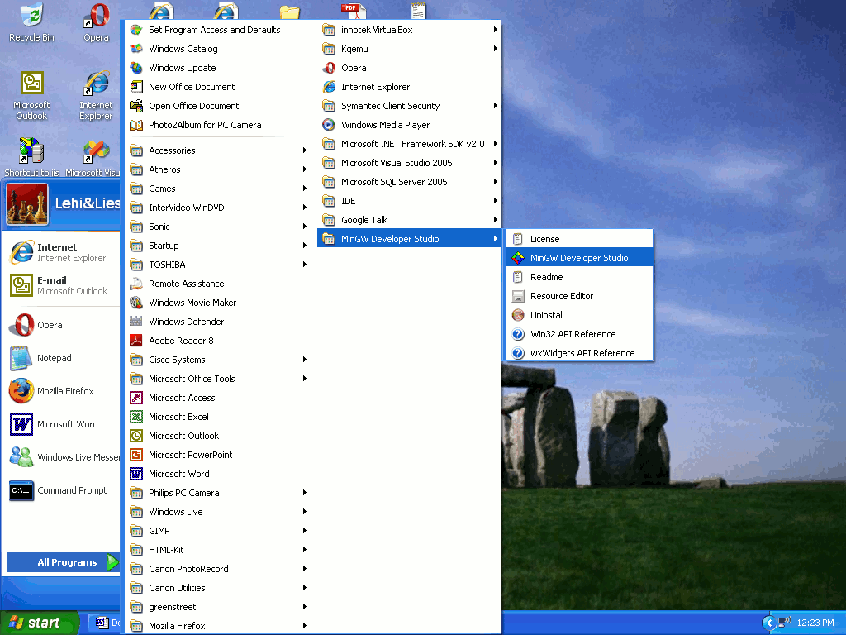
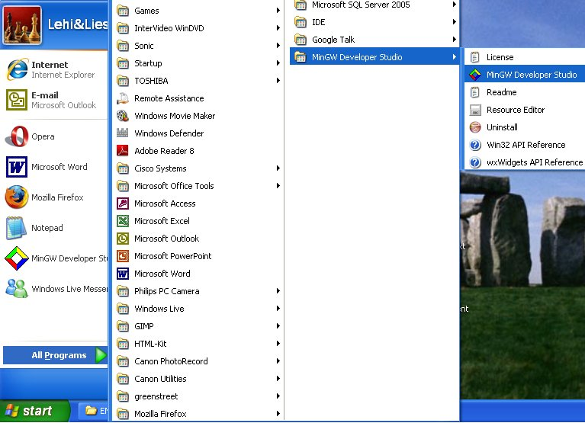
1.1 Opening MinGW
From the Windows desktop, click on start and then select MinGW Developer Studio. See Figure 1 – starting MinGW.

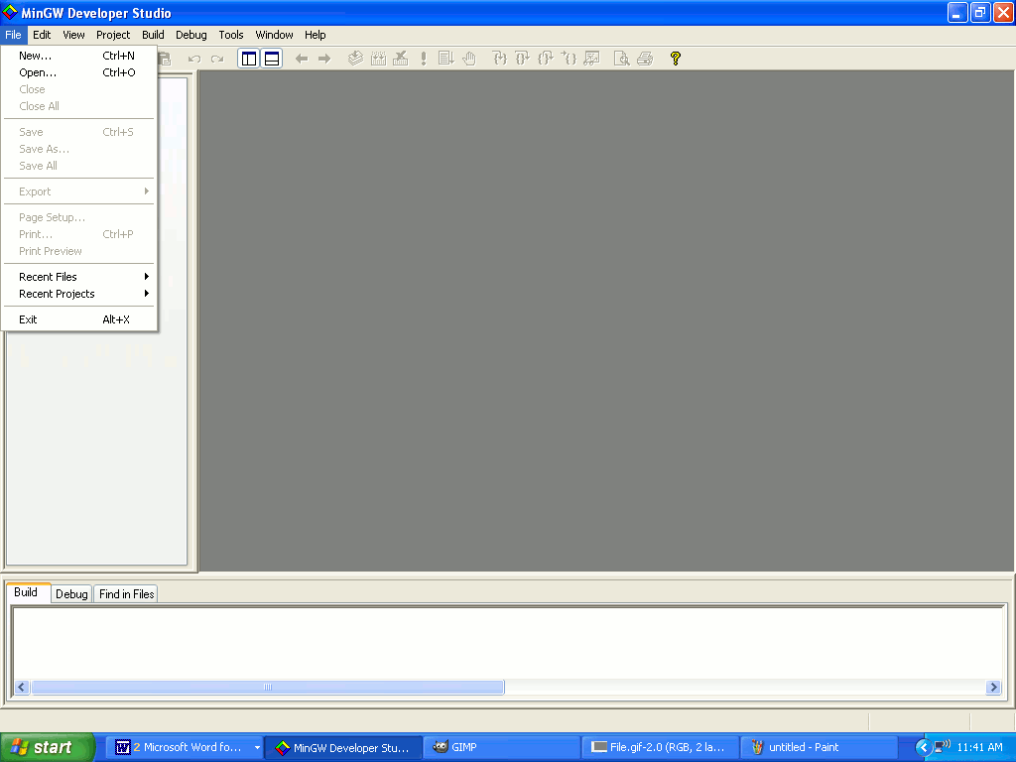
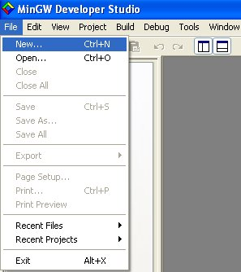
1.2 Creating a Project folder
Figure 1 – starting MinGW
Click on File; you should see a drop down menu. Click on New. See Figure 2 – Creating New Projects. Click on the Win32 Console Application to create a project type. You must now decide on the name of the project folder, as well as the location of the folder.
Figure 2 – Creating Project Type & Folder
 Warning: Make sure you know where you are creating the folder. Or else you will have trouble locating it. My recommendation is to create one main folder that will contain all the projects you will be creating.
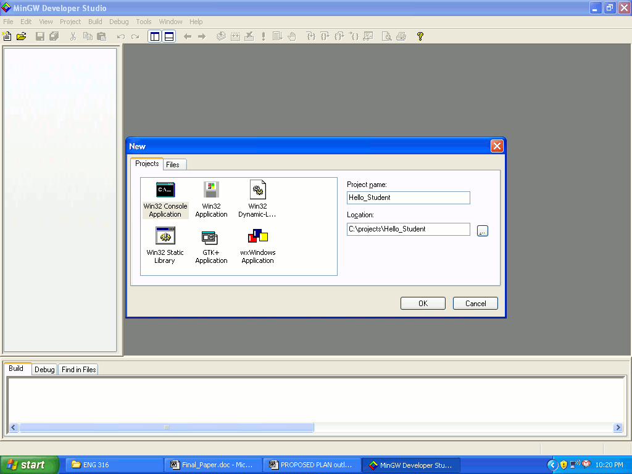
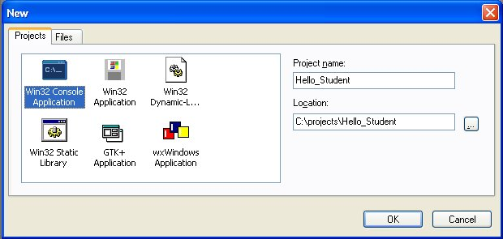
Figure 3 – Creating a location for Projects.

 Note: You should create a folder in drive C for all the projects you will be creating. Call it projects. Name the project type Hello_Student. Click OK. The path address will be: C:/projects/Hello_Student. See Figure 3 – Creating a location for Projects.


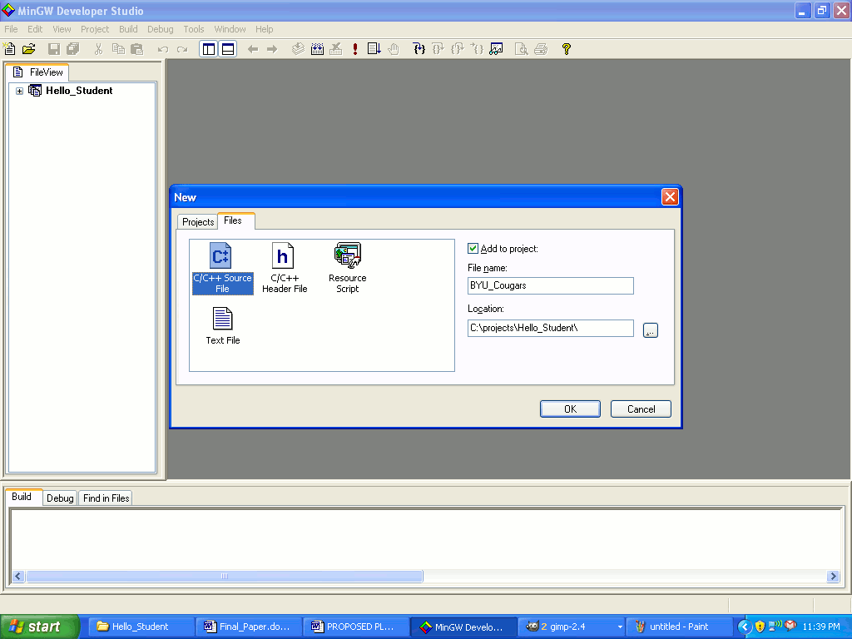
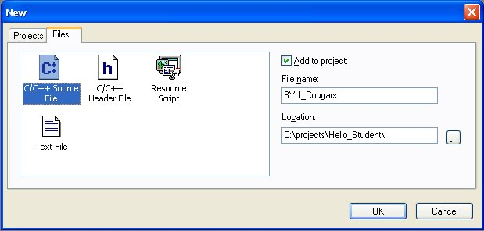
1.3 Creating a file type
On the top left hand side is an icon of a piece of paper with the corner turned down. It is called New (See Figure 4 - New icon). Click on it and name the Code file BYU_Cougars. Make sure the check box where it says Add to project is checked in order to add the file to the project. Click on C/C++ Source File in order to make a C++ file. Then press OK to continue. MingW will automatically assign the extension of the file you have chosen, which should be a “.cpp” See Figure 4.1 – File Name.
Figure 4 – New Icon

1.4 Hello_Student Project
Type the following code on the file entitled BYU_Cougars.cpp. Run the code by pressing F8. Hit Enter to make the screen go away.
Figure 4.1 – File Name

#include <iostream>
using namespace std;
Figure 4 – File Name
int main ()
{
cout << “I am a Student from Brigham Young University!” << endl;
// This line won’t be printed it is just a comment line for yourself.
return 0;
}
See Figure 5 – Hello_Student.
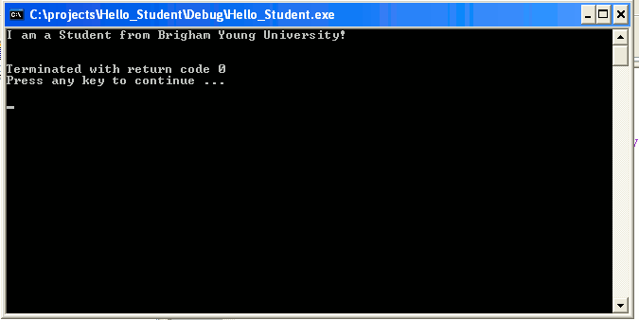
Note: All the code that should be typed on each project file in this manual is highlighted in font color dark blue. This is for you to locate the programming code easily on the manual.

Figure 5 – Hello_Student

An explanation of all the terms typed is as follows:
- “#include <iostream>” Accesses the library “iostream.”
- “using namespace std;” Accesses a specific portion of the “iostream” library, the most common portion is the “namespace std.”
- “int main ()” The main code in the program, you can only have one “main ()” in a program.
- “{}” The beginning and the end of the program code.
- “;” The end of a line.
- “cout”: To write something on the buffer/memory.
- “<<” To catch what is on the buffer/memory and print it on the screen.
- “endl;” The end of the line and connects it to the next line.
- “return 0;” If everything in the code is right it will return 0, otherwise it will return a random number which you will know that there is something wrong in the code that needs to be fixed.
- “//” A comment for yourself in case you need some clarification for more complicated codes.

Section 2 – Basic Math
Note: There are a few math terms you will need to know to compute some operations. They should be familiar to you because it is similar to Mathematics (Savitch, 2007.p. 9):
- “int” short for integer, it is a Whole number; size range: from –2,147,483,647 to 2,147,483,647; examples: 1,4, 89,100.
- “double” Fraction number; size from 10⁻³⁰⁸ to 10³⁰⁸; examples: 2.34, 8.0.
- “float” Fraction number; size from 10^{–38} to 10³⁸; examples: 2.4, 2.1, 4.6.

You have learned how to print a message on the screen. On the following section you will learn about math operations, some terms are defined as follows:

2.1 Essential math operators

- “+” Adds numbers/strings of characters.
- “-” Subtract numbers.
- “*” Multiply numbers.
- “/” Divide numbers.
- “=” Assigning operator, it assigns something to something, example: int x = 5.

2.2 Simple math operations project

Create a new project folder type and name it math. Then create a file type and name it addition. Type this code on the file entitled addition.cpp. Run the code by pressing F8. Hit Enter to make the screen go away.

#include<iostream>
using namespace std;
int main ()
{
int number = 100;
//the line above assigns the number 3 to the variable called number.
int number2 = -45;
Cout << number + number2 << endl;
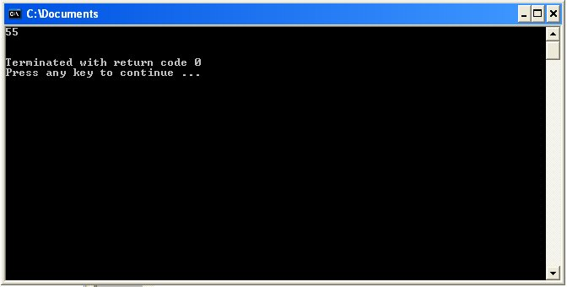
return 0;
}
See Figure 6 – Math additions.

Mathematics is very important in the Computer Science field because programming is hard-core math. So if you are good with math that may be a good indication to try out Computer Science. With the math terms explained above, you are now ready to learn about conditions, which are very similar to the known condition “if…then…”
Figure 6 – Math additions

Section 3 – Basic Condition Terms

The most essential terms in conditions are defined as follows:

3.1 Condition terms you need to know for comparison:

- “char” All printable ASCII characters; example a, z, w, A, Z, W.
- “string” Phrase or a keyword. Example: “Lehi”, “yes.”
- “bool” True or false.
- “!=” Not equal to.
- “&&” And
- “||” Or (If any condition is true it fulfills this condition).
- “= =” Comparing operator.
- “if …else…” If one condition is true, depending how the condition is formulated then something happens, else something else happens. Example:
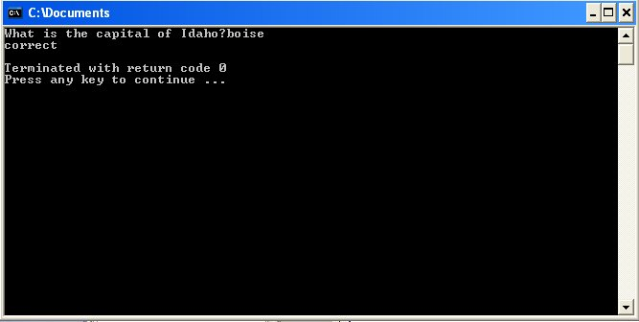
3.2 Condition concept projects:

Create a project folder type and name it state; then create a new file type and name it capital. Now type the following code on the file entitled capital.cpp. Run the code by pressing F8. Hit Enter to make the screen go away.
Figure 7 – if else condition
#include <iostream>
using namespace std;
int main ()
{
string answer;
cout << "What is the capital of Idaho?";
cin >> answer;
if (answer == "boise" || answer=="Boise" || answer == "BOISE")
{
cout << "correct";
}
Note: this program code uses multiple constraints so that all the conditions are fulfilled (if (answer == "boise" || answer=="Boise" || answer == "BOISE") ). This is a good code habit to adopt, because it takes care of all conditions you want to implement at once.
else
{
cout << "That is incorrect, the correct answer is Boise";
}
return 0;
}

This is a straightforward code that is looking for a specific answer, the capital of Idaho, which is Boise. If the user does not input BOISE or Boise or boise it will tell the user that he/ she input the wrong answer. For a visual of what the program looks like, see Figure 7 – if else condition.

While a simple “if else” condition is helpful when programming’ it would be tedious if you would have to check same condition repetitively. One simple way to avoid the tedious rechecking is to implement a loop, meaning it will check a condition for you over and over again. There are three main loop conditions. They are as follows:

A. “do while” loop, meaning it will check a condition at least one time, at the end of the condition. Create a project folder type and name it number; then create a new file type and name it spell_out. Now type the following code on the file entitled spell_out. Run the code by pressing F8. Hit Enter to make the screen go away.

#include <iostream>
using namespace std;
int main ()
{
bool key = false;
string number;
do
{
cout << "input a number between 0-9 and I will spell out the number. (input 10 to end)" << endl ;
cin >> number;
if (number == "1") {cout << "One" <<endl;}
if (number == "2") {cout << "Two" <<endl;}
if (number == "3") {cout << "Three" <<endl;}
if (number == "4") {cout << "Four" <<endl;}
if (number == "5") {cout << "Five" <<endl;}
if (number == "6") {cout << "Six" <<endl;}
if (number == "7") {cout << "Seven" <<endl;}
if (number == "8") {cout << "Eight" <<endl;}
if (number == "9") {cout << "Nine" <<endl;}
if (number == "0") {cout << "Zero" <<endl;}
if (number == "10") {
key = true;
cout << "Thanks for your time";
break;}
if (number != "1" && number != "2" && number != "3" && number != "4"
&& number != "5" && number != "6" && number != "7" && number != "8"
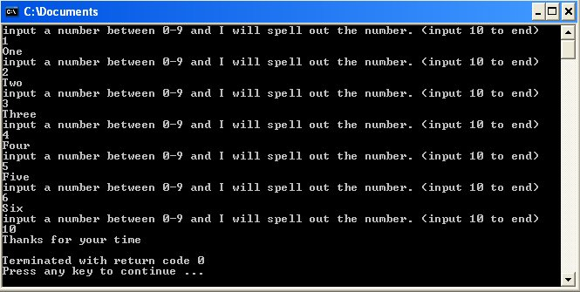
&& number != "9" && number != "0")
{
cout << "Wrong input" << endl;
}
} while (key == false);
return 0;
} For a visual see figure 8 – do while.
Figure 8 – do while
An explanation for what was typed is as follows: Essentially this program looks for a number in the range between 0 and 9. It will spell out the name of the number; to end the program the user needs to type the number 10; if anything else is typed in the program, it will print on the screen the message “wrong input”; then it will ask for another input. It will keep repeating it self infinitely until the number 10 is inputted.

B. “while” loop is slightly different from the “do while” loop. Create a project folder type and name it number2; then create a new file type and name it spell_out2. Now type the following code on the file entitled spell_out2.cpp. Run the code by pressing F8. Hit Enter to make the screen go away.

#include <iostream>
using namespace std;
int main ()
{
bool key = false;
string number;
while (key == false)
{
cout << "input a number between 0-9 and I will spell out the number. (input 10 to end)" << endl ;
cin >> number;
if (number == "1") {cout << "One" <<endl;}
if (number == "2") {cout << "Two" <<endl;}
if (number == "3") {cout << "Three" <<endl;}
if (number == "4") {cout << "Four" <<endl;}
if (number == "5") {cout << "Five" <<endl;}
if (number == "6") {cout << "Six" <<endl;}
if (number == "7") {cout << "Seven" <<endl;}
if (number == "8") {cout << "Eight" <<endl;}
if (number == "9") {cout << "Nine" <<endl;}
if (number == "0") {cout << "Zero" <<endl;}
if (number == "10")
{
key = true;
cout << "Thanks for your time";
break;
}
if (number != "1" && number != "2" && number != "3" && number != "4"
&& number != "5" && number != "6" && number != "7" && number != "8"
&& number != "9" && number != "0")
{
cout << "Wrong input" << endl;
}
}
return 0;
}
For a visual see figure 9 – while.

An explanation for what it was typed is as follows: it is essentially the “do while” code the only difference is that the condition is checked right at the beginning of the condition code instead of the end. As you can see per figure 9 the screen looks just like the “do while” screen.
Figure 9 - while

C. “for” loop is implemented by some constraints that will be demonstrate on the following two examples:

  - Single “for” loop:

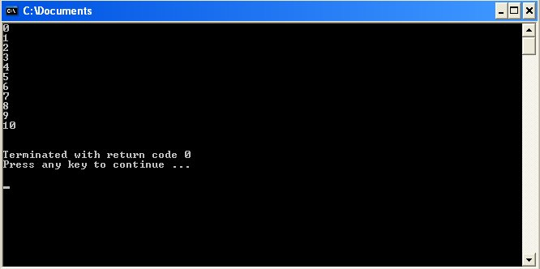
Create a project folder type and name it number3; then create a new file type and name it spell_out3. Now type the following code on the file entitled spell_out3.cpp. Run the code by pressing F8. Hit Enter to make the screen go away.

#include <iostream>
using namespace std;
int main ()
Figure 10 – for loop
{
int y = 10;
for (int x=0; x <= y; x++)
{
cout << x << endl;
}
return 0;
}

An explanation of the code just typed: for (int x = 0; x < input; x++). The first constraint is actually just an introduction of a variable integer x is zero. The second constraint is stating if the value that it is in x if it is less equal than y, then the second constraint is true and it will add one to the value of x at the end of the for loop, and then it will recheck the condition for x less equal y it will keep doing that until x is more than y. If you typed everything right you should on the screen Figure 10 – for loop.

  - Nested “for” loop:

Create a project folder type and name it number4; then create a new file type and name it spell_out4. Now type the following code on the file entitled spell_out4.cpp. Run the code by pressing F8. Hit Enter to make the screen go away.
#include <iostream>
using namespace std;
int main ()
{
int input;
string star = "*";
cout << "Please input the amount of stars you'd like to see in a pyramid shape" << endl;
cin >> input;
for (int x = 0; x < input; x++)
{
cout << star;
for (int y=0; y<x; y++)
{
cout << star;
}
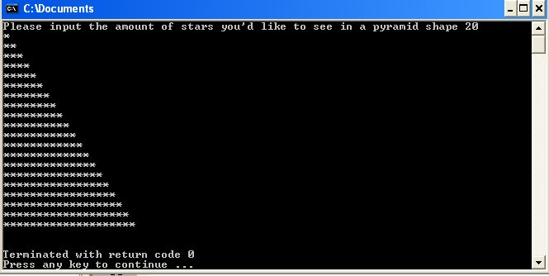
cout << endl;
}
return 0;
}
For a visual see figure 11- nested for loop.

An explanation of the nested “for” loop code just typed: for (int x = 0; x < input; x++). The first constraint is actually just an introduction of a variable integer x is zero. The second constraint is stating if the value that it is in x is less than input, then the second constraint is true and it will add one to the value of x at the end of the “for” loop; then it will recheck the condition for the x less than input, it will keep doing that until x is more or equal input. The second “for” loop is the nested one: for (int y=0; y<x; y++). It has almost the same condition as the first “for” loop, except it has its own middle condition if y is less than x then increase y which at first starts at zero; by doing this it will enable to first print one star from first “for” loop, and then print subsequent stars based on the second “for” loop. After the second for loop is done and incremented the y value; it will return to the end the first loop, jump to the next line and increment the x value of the first “for” loop. It will do this until the loop conditions are done.
Figure 11 – nested for loop

Section 4 – Functions

4.1 The Concept:

As a university student, you should be really acquainted with math and should know that a function has attributes and behaviors; interesting enough Computer Science takes a lot of math ideas/concepts from Mathematics. Function is one of them. Create a project folder type and name it function; then create a new file type and name it converter. Now

4.2 FUNCTION PROJECT

Type the following code on the file entitled converter.cpp. Run the code by pressing F8. Hit Enter to make the screen go away.

#include<iostream>
using namespace std;
double exchange(double x)
{
x = x *1.62651;
return x;
}
int main ()
{
double money1;
cout << "Currency conversion from US dollars to Reais (Brazilian Currency)" << endl;
cout << "Please type the money in dollars:";
cin >> money1;
cout << endl << money1 << " dollar(s) in Reais is: "<<exchange (money1) << " Reais" <<endl;
cout << "Thank you for using Lehi's Currency Conversion";
return 0;
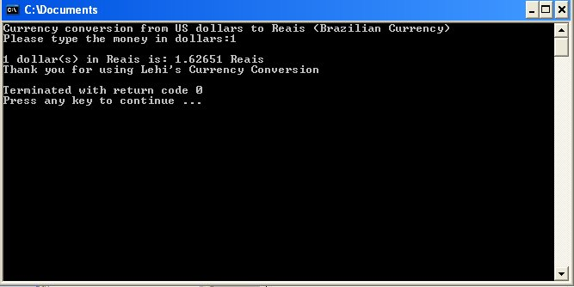
}
You should see a screen similar to the figure 12 – Currency Converter

An explanation for the Function Concept example:

Essentially in this code it is describing a function outside of the main code and we are giving it attributes such as the type of the function is a “double,” meaning that it is expecting a “double” number, nothing else can go into the function. In the “main ()” code the function “exchange ()” is called and it is given a “double” number that is inputted by the user of the program. The exchange program catches the number and it multiplies it with the rate of the exchange dollar and it returns the converted input, from dollars to Brazilian reais and gives it back to where it was called. In the code this new number is simply printed on the screen as the real amount of money.
Figure 12 – Currency Converter
Note: The term “return x;” all it does, like the name says, it returns something to where it was called, in this case since a user typed a number which is given to the exchange function to perform an operation, in this case multiplication; it returns a new value to where the function was originally called.

Conclusion

In conclusion, this manual is similar to the type of work you will be doing in the computer science major. If you have enjoyed learning the information in this manual, you can assume that you will enjoy the computer science major. If you have not enjoyed the material in this manual, most likely the computer science major is not for you. Whether you are pursuing the computer science major or a different major, this information will be useful to you in understanding computer science.

Appendix A: Glossary

Primitive Data: The basic data type in programming.
Call a function: To execute a function.
Integer: Math integer number.
String: Group of characters.
Character: A single alphabetical letter.
MingW Developer Studio: It is an integrated development environment that uses the language C/C++ to program it
Run the code: meaning execute the code.
Ide(s): it is an abbreviation for integrated development environment. It is a program that assists programmers to make computer programs/ software.
ASCII: all the characters found on the keyboard of a computer. They could be printable to the screen/monitor or nor.
Bool: is short for Boolean, it is the logic of false or truth.

Appendix B: References

Savitch, W. (2008). Absolute C++ (3rd ed.). Pearson Education, Inc.

